Nilesh & Friends: A WebApp Research Document.

**Calendly**

**calendly.com**

1. A case study on style and main landing pages:

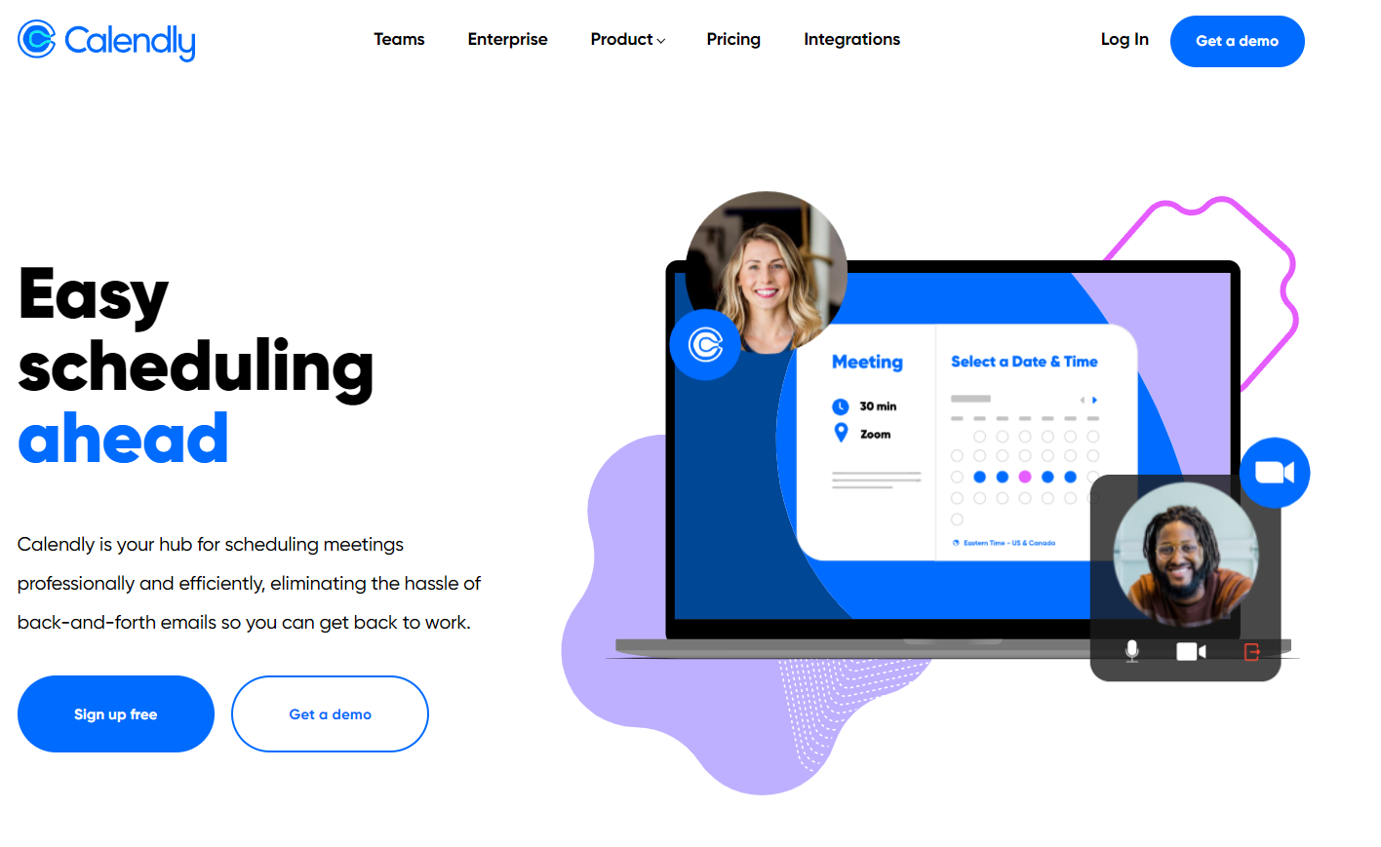

* Colors used are very simplistic and theme follows a black and dark-ish blue pattern which is quite easy on the eyes and these colors actually go well together, making the website look more sophisticated and reliable.
* Once the main page loads, your eyes land on the left side that says “Easy scheduling ahead” where it makes it clear and obvious that this is a scheduling website made to be easy.
* Right after, your drifts across to the right to the two people and calendar which is a very simple 10 second gif that gives a clear overview of what the website is for, what is done and how easy it is that it can be done.
* Navigation bars are at the top middle (which is expected from best practices).
* On the top right, we have a Log in (as expected) and Demo button.
* The main page is much longer than just the image above, but the most important information is displayed right at the first thing you see to get to the point.

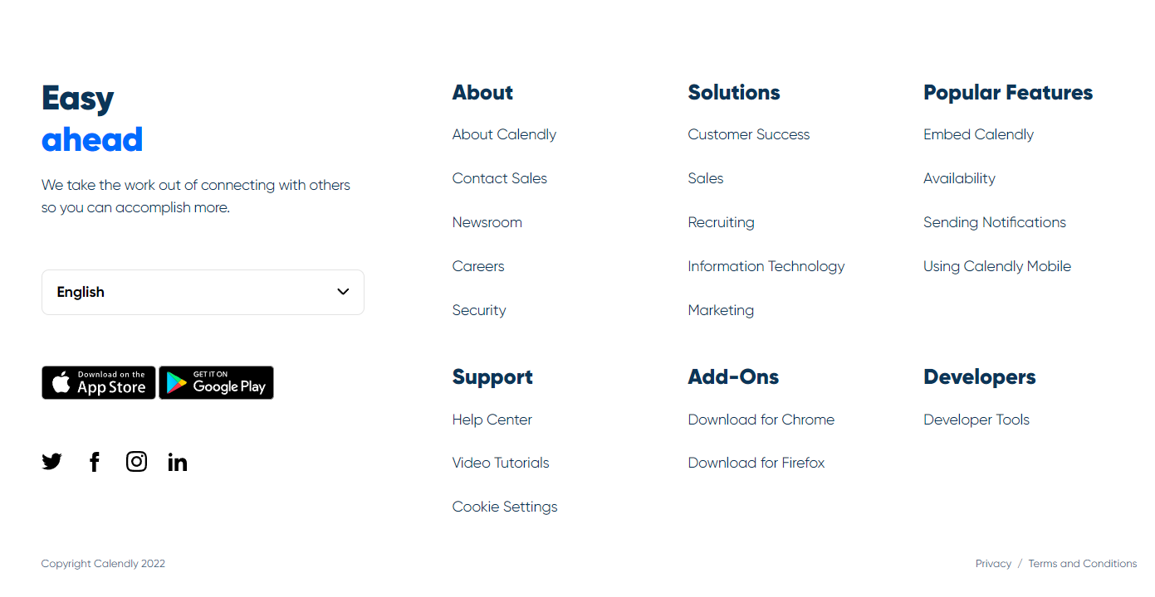

* Right at the bottom, you have links to their socials, links to download it on mobile plat-forms and other things that users may look for specifically rather than in general.

2.Log-in/sign-up:

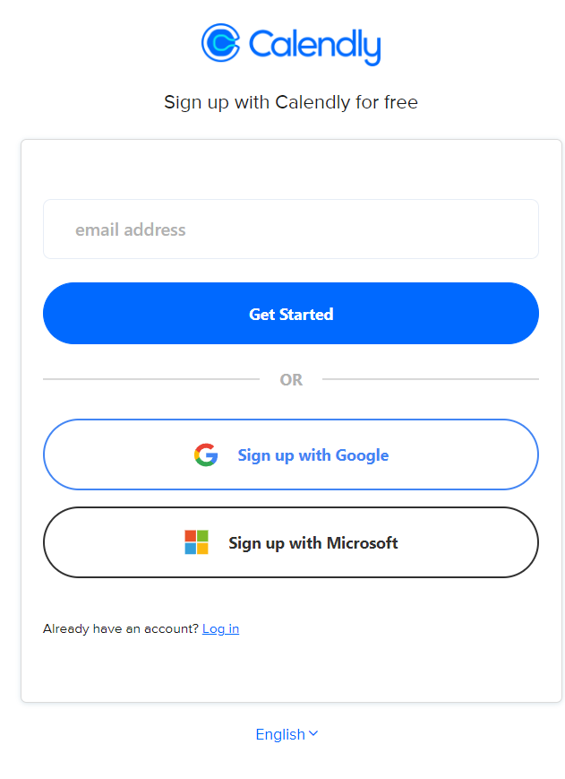

* Sign-up page is pretty simple, uses the same theme as main page (blue and black) and gives options to either start with an email address or sign up via other social plat-forms (Microsoft or Google) which gives user more freedom and ease of signing up as most people may have one of these accounts and it saves user from typing in information that they already have given these other plat-forms.
* Downside: There is no straight link to Sign-up from the main page, rather you have to click on sign in and then click on the bottom where it says “Don’t have an account? Sign-up”
* The Log-in page asks for your email and then checks if that email is associated with an account on their database and then automatically shows which social plat-form (if any) that email was used with and you can then log-in through that (of course, entering your password again).
* If you use your google account, Calendly can access and modify your Google Calendar.

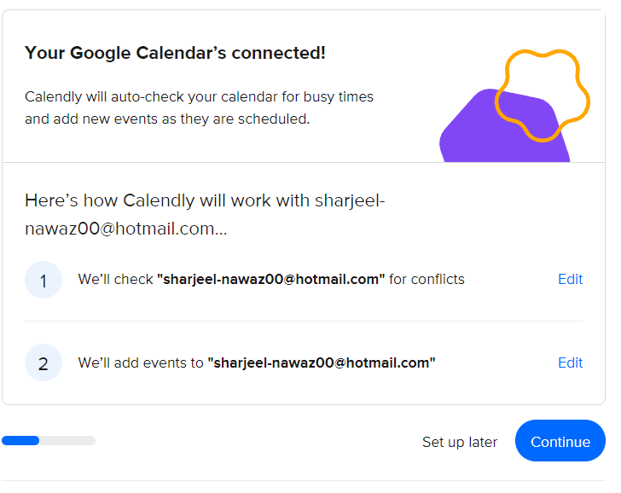

* Gives option to user to set-up calendar later or now (again, making it easier for the user if they only want to set-up an account for now).
* Links/integrates calendar with google calendar and shows which emails will be used for certain aspects.
* Note: There were other things in the set-up that seemed a bit unnecessary. Rather than having things like “in general when are you busy”, it should just not be added and rather the user can work on a day-to-day basis scheduling.

3.After sign-up/Log-in

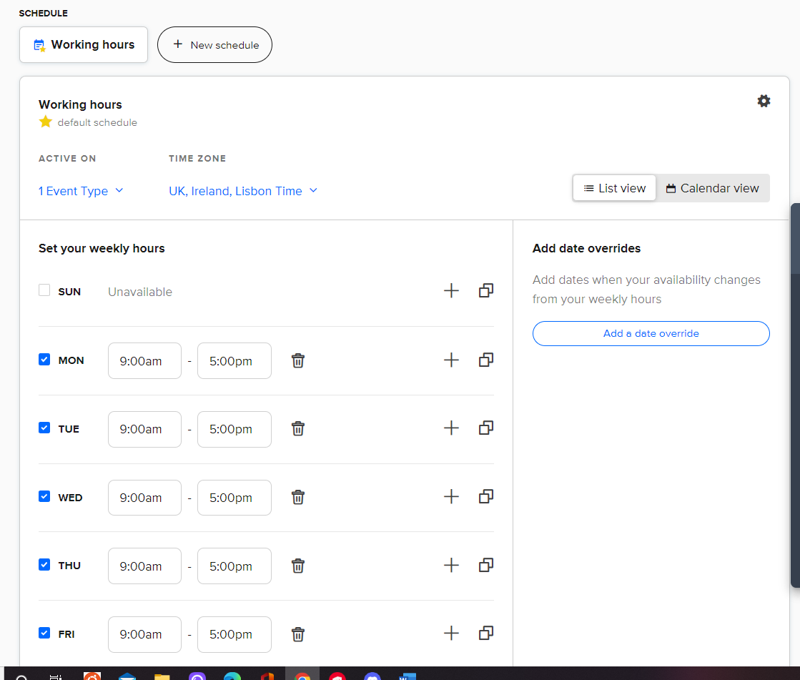

* In all honesty, scheduling at first felt a little complicated but that may be expected from a scheduling website where there’s a lot of things to go through. As long as the learning time is low and features are easy to understand, it would go well.
* Could not understand how to work the schedule at first but slowly understood.
* User can set their availability for certain days from certain times and add other times when they might be available on the same day.
* No straight forward option to edit times when available in the List View, which means you have to go in to the Calendar View, click on the date and then change available times from there. Which again, at first might not be so straight forward but does not require much learning either.
* Can create more schedules at the top where it says “New Schedule” and you can choose between schedules.
* The color scheme of the entire page is again blue and black.
* You can change Time Zone which I think would convert times to other people’s selected timezones.
* So far, the scheduling process took about 2 minutes to learn, the page is very basic and somewhat to the point. Makes it easy for making schedules where availability times may be repeated through a few weeks (kind of liked this feature a lot).

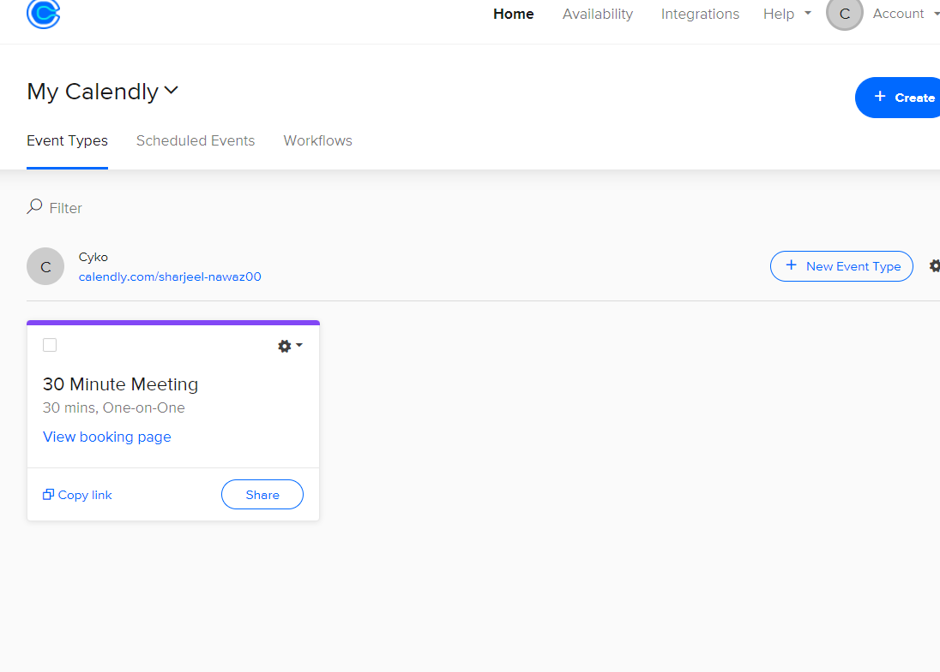

* Clicking on the home page after signing in, you can go to the types of Events you may have. This page seems quite simple and you can easily share your events through the “Share” and/or the “Copy Link” buttons.
* You have scheduled events (which shows users any upcoming and past events).
* You have workflow which is where you can send emails or receive emails about events or to remind people about your own event (this feature relates to our project quite a lot.)

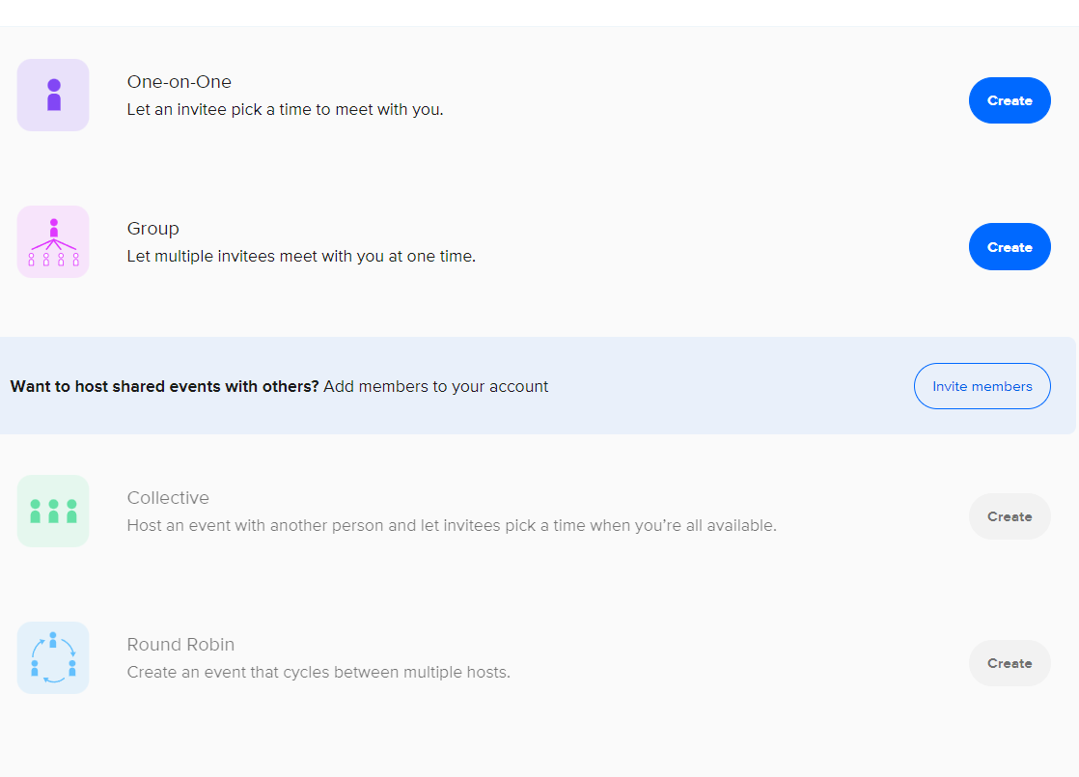

* When you try to create an event, you get some options.
* What our project may be based on is hosting an event where everyone picks a time and it can be compared to see which time everyone is available which is the same as the “Collective” event on Calendly.

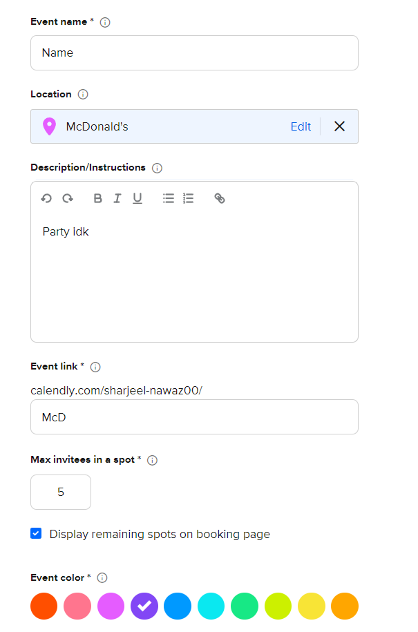

* Creating event is quite simple, can choose a color to be displayed on your calendar for it and the event link goes through your account link and then goes to your event. So, you have to be redirected twice. You can choose the max amount of invitees and maybe this feature could be added in a different way to our project where if there are a certain number of people attending out of all of the people that were invited, the event goes forward, otherwise it cancels.
* You can set a location for the place and this feature seemed like it did not use Google Maps (or maybe it didn’t use it because I have that disabled) and I think setting the location without the integration of Google maps is pretty easy as long as the host knows exactly what the location is so that it does not confuse the attendees. This feature is quite simple to use.
* The description is everything that you’d expect from a description. I do not think there is a description word limit which is good and bad. Good in the aspect that the host can write as much as they want but bad in the aspect of the programmer/client-side since this information has to be stored on the server/database where it may become possible for a user to write a lot in this field and break the website database.
* Cognitive load during this process was quite low as everything was so simple to understand and to the point. Kinematic load was low as well since it actually seemed to be in a good order and things weren’t scattered across the page.

4.Overall thoughts and a few noticed things on Calendly

* Simple to use.
* Everything had the same color theme. Theme used was okay visually.
* Editing account was nothing special and did not need to be talked about.
* Website followed basic practices (e.g: navigation at the top middle).
* Nothing important was too hard to navigate.
* Most important things were centered and in your face.
* All relevant pieces were together thus reducing kinematic load, nothing was spaced out too far and all of the items on the website (after log-in) were centered, meaning the rest of the sides of the website had nothing useful inside of them.
* As the browser was made smaller, the sides of the website got smaller and smaller but the center of the website (the main things) did not change size at all and after the browser was made smaller than the center, the important bits got smaller and more compact and things some items shifted the way they were presented completely (two tabs that were displayed turning into a drop-down box where you’d have to select one of them to view them).
* Learning experience was about on average 5-10 minutes to get used to the website.

**Deputy**

**deputy.com**

1. A case study on style and main landing pages:

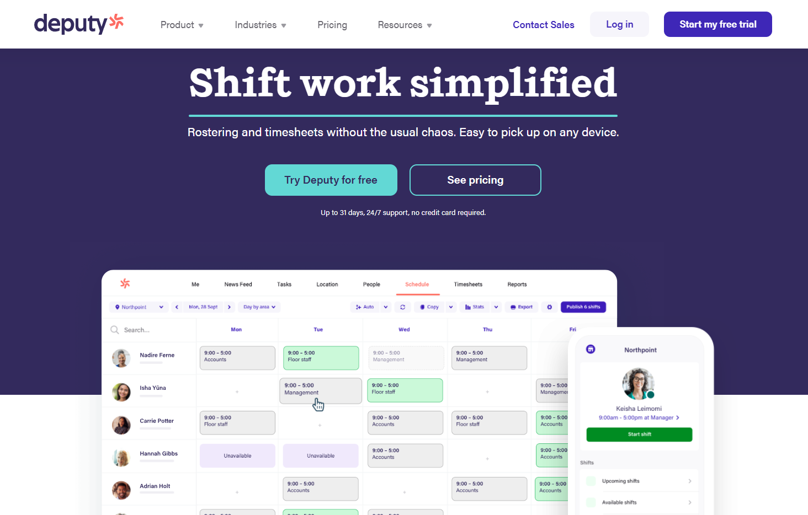

* This is the main landing page to deputy. Your eye actually lands straight on the 10-15 second gif like video that plays on the main page. This video actually goes over all the basic features to get someone interested in this website for scheduling. It definitely got me intrigued. Showing what your website/software can do literally on the main page can gain attention better than writing long lines since users tend to be more engaged with things they don’t have to read but rather have to see visually.
* After watching this simple video, your eyes go upwards to the “Shift work simplified” and then straight to the “Try Deputy for free” as that seems to be highlighted in this color scheme.
* Speaking of color scheme, the main colors used seem to be Purple, white and light green, which seem to work quite well and give a sense of professionalism (at least to us).
* At the top of the main page, you have all of your expected things. A navigation bar in the middle, the name of the business on the left and the Login on the right with the additional “Start my free trial”

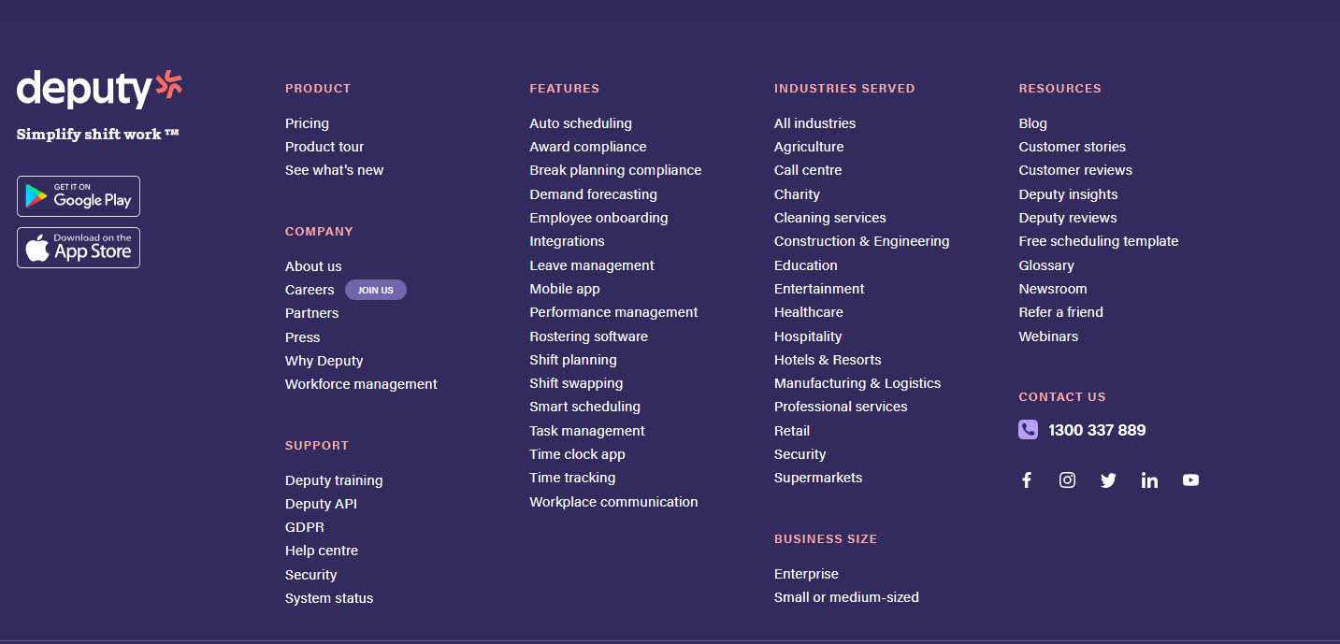

* Going to the bottom of the main page, you get your usual things once again. Specific links to certain things people may be looking for, links to the software’s mobile applications and things like how to contact deputy for support etc.

2.Log-in/sign-up:

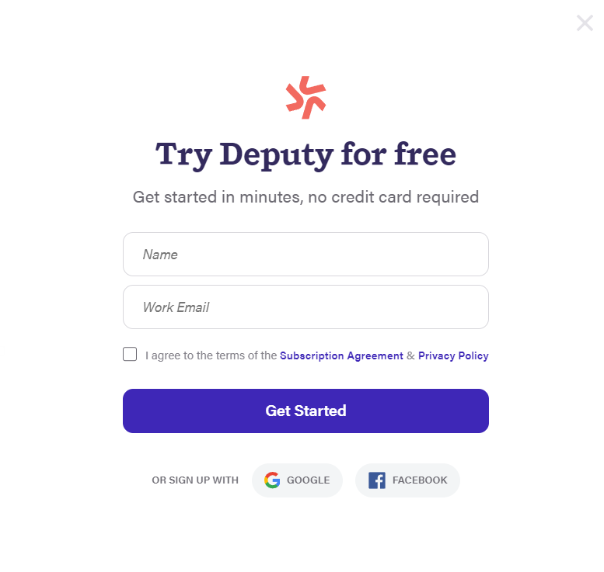

* To sign-up, you have to click on start the free trial and signing up is actually a pop-up block where you can either sign-up using your name and email or just sign-up using Google or Facebook. Again, this makes it easier for the user to use a social plat-form that they already have and saves them from filling in things that they might have on other plat-forms. This reduces cognitive load in a certain way, actually. I definitely felt at more ease being given the option to sign-up with my Google account. And in terms of Kinematic load; since everything is in the middle and compact, the user does not have to move around their cursor too much to reach their goal of signing-up.
* After using the Google account, I could not do much since I needed to own a business or be in one and I am not.

3.After Log-in/sign-up:

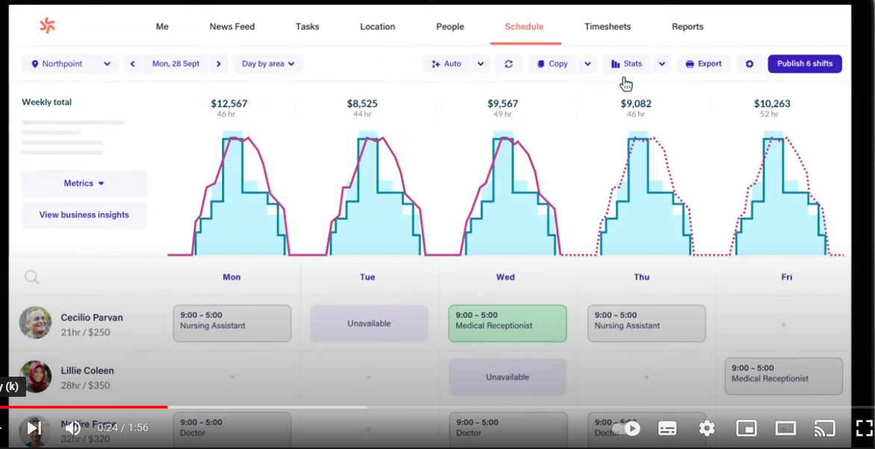

* Since a workspace could not be created on the website since we do not own a business, a video on the introduction to the software was watched. In the software, an overview was given of everything and it seemed very simple.
* The host in this case could see everyone’s schedules and when they were working certain shift hours. This is something that would not be added to our event scheduling website as the website is going to be more of an event scheduling website rather than “working for somebody” kind of scheduling website.
* Inviting people/offering people timespaces seemed very easy and once it was sent by the host, they could either approve or disapprove. A feature like this will be implemented in our website where users will be able to reject or accept invites. In addition to that, the invitees were able to actually add comments on why they cannot attend. A feature like this could be added to our event scheduling website where users can maybe send the host a reason why they cannot attend and/or an automated message could be sent to the host telling them that a certain invitee’s schedule is not available for the times chosen.
* Start and finish times could be chosen in this software for the invitees and taking from that idea. A feature that is not very useful for us unless it’s in terms of displaying when the event will start-finish which is already a given feature that should be added.

4.Overall thoughts and a few noticed things on Deputy

* Not much can be said as the scheduling was not experienced first hand but there are a few points to be made
* The color scheme used was very nice and better than Calendly. Maybe we can go with a similar pattern?
* The way the scheduling looks seems to be much better than Calendly but it would be much more complicated to code. The simple look of Calendly compared to Deputy makes it a bit easier to use but the more visual items on deputy with a few more colors in the items makes it visually more pleasing to use.
* Cognitive load for this website is a little unknown by me but for the landing page, it seemed low and the kinematic load was the same as Calendly as this website followed basic principles of how to structure main pages, login/signup pages and after login pages.
* Deputy seems to be based around businesses so it’s not something we’re interested in but we can definitely take from the points mentioned above.

**The next few pages are reviews and points on other websites/webpages that aren’t directly involved in scheduling but are a good example of how structuring, styling and using basic practices looks and how we can integrate them into our own website. The examples used are quite basic and well known but they are well known for a good reason (being their ease of use, structure, layout, etc.) and that is why they are chosen.**

## 1. A case study on style and main landing pages of general websites:

### **Discord**

discord.com

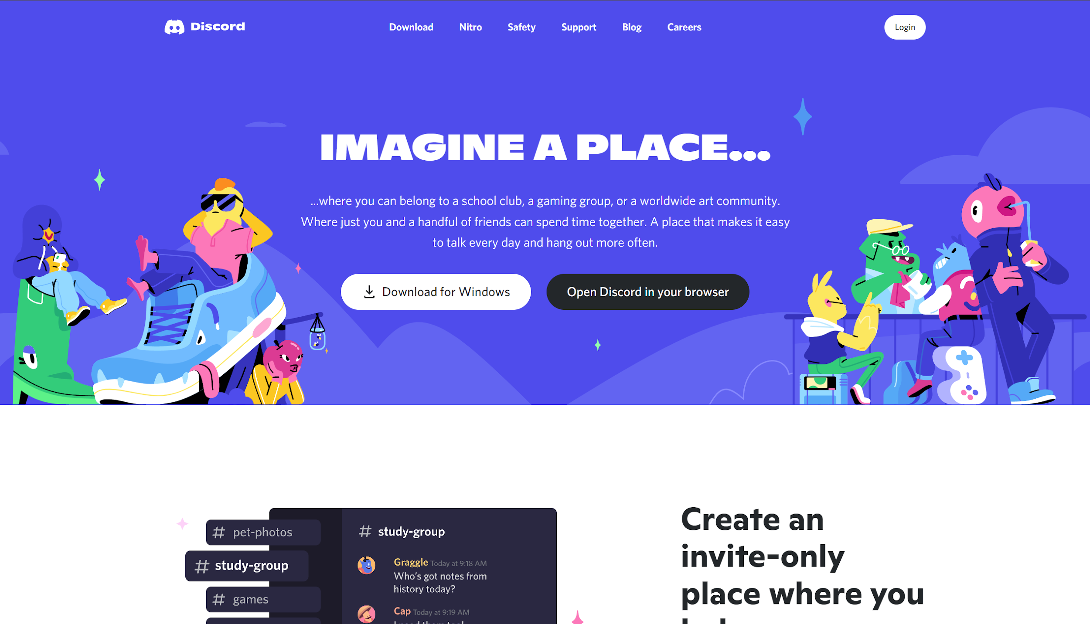

* Custom images/art
* Strong two distinct colors
* One-time fade in animations for content
* Grid & flex display/layout
* Notes on interactivity:
  + Links underline when hovered over (such as footer links and navigation links at top of page)
  + Buttons cast a shadow animation when hovered over

### **W3schools**

w3schools.com

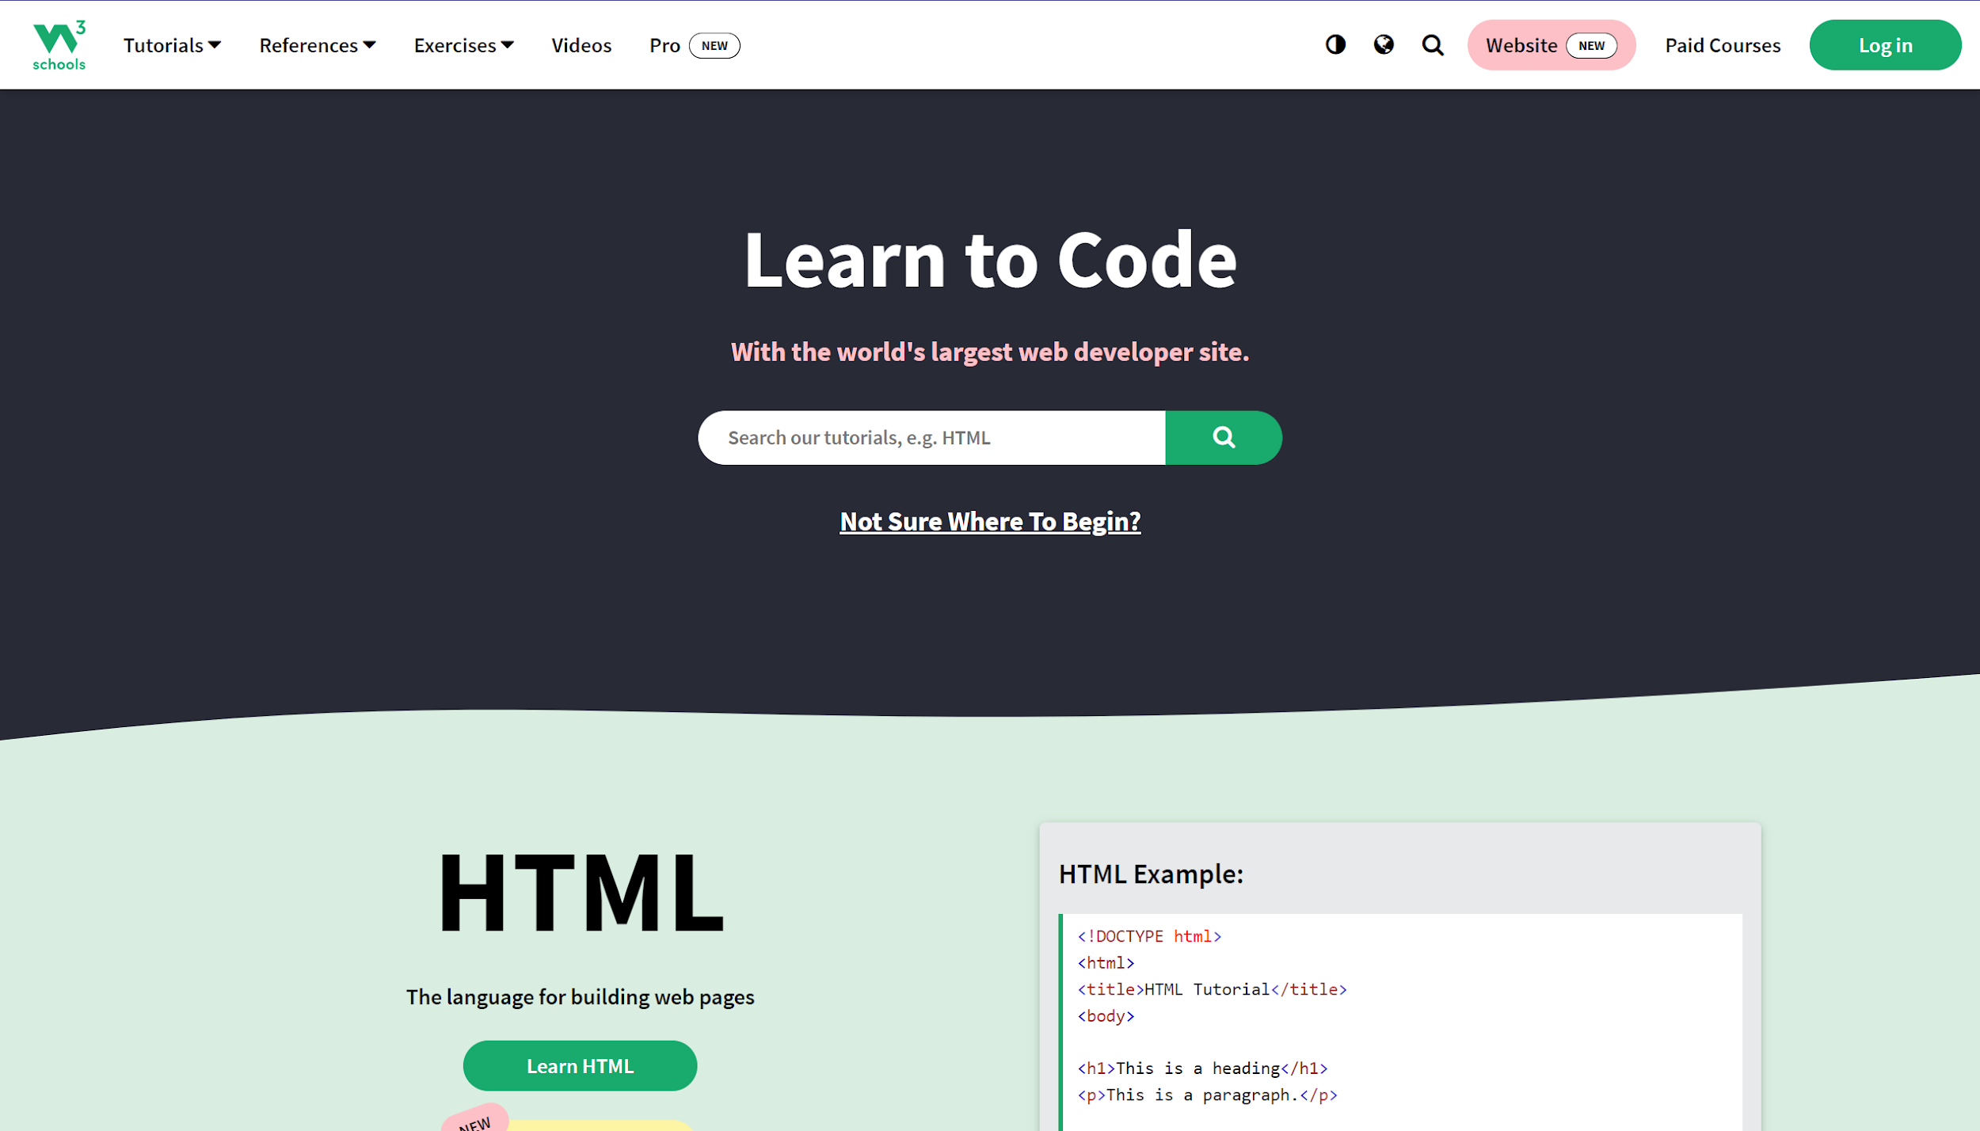

* Large heading font sizes & buttons
* Distinct separation of content:
  + Content clearly separated by various different background colors
  + Content separated into a “grid” style layout
* Notes on interactivity:
  + Buttons darken on hover
  + Navigation bar on top is a dropdown menu, also changes button background color on hover

### **Google Chrome**

google.com/chrome

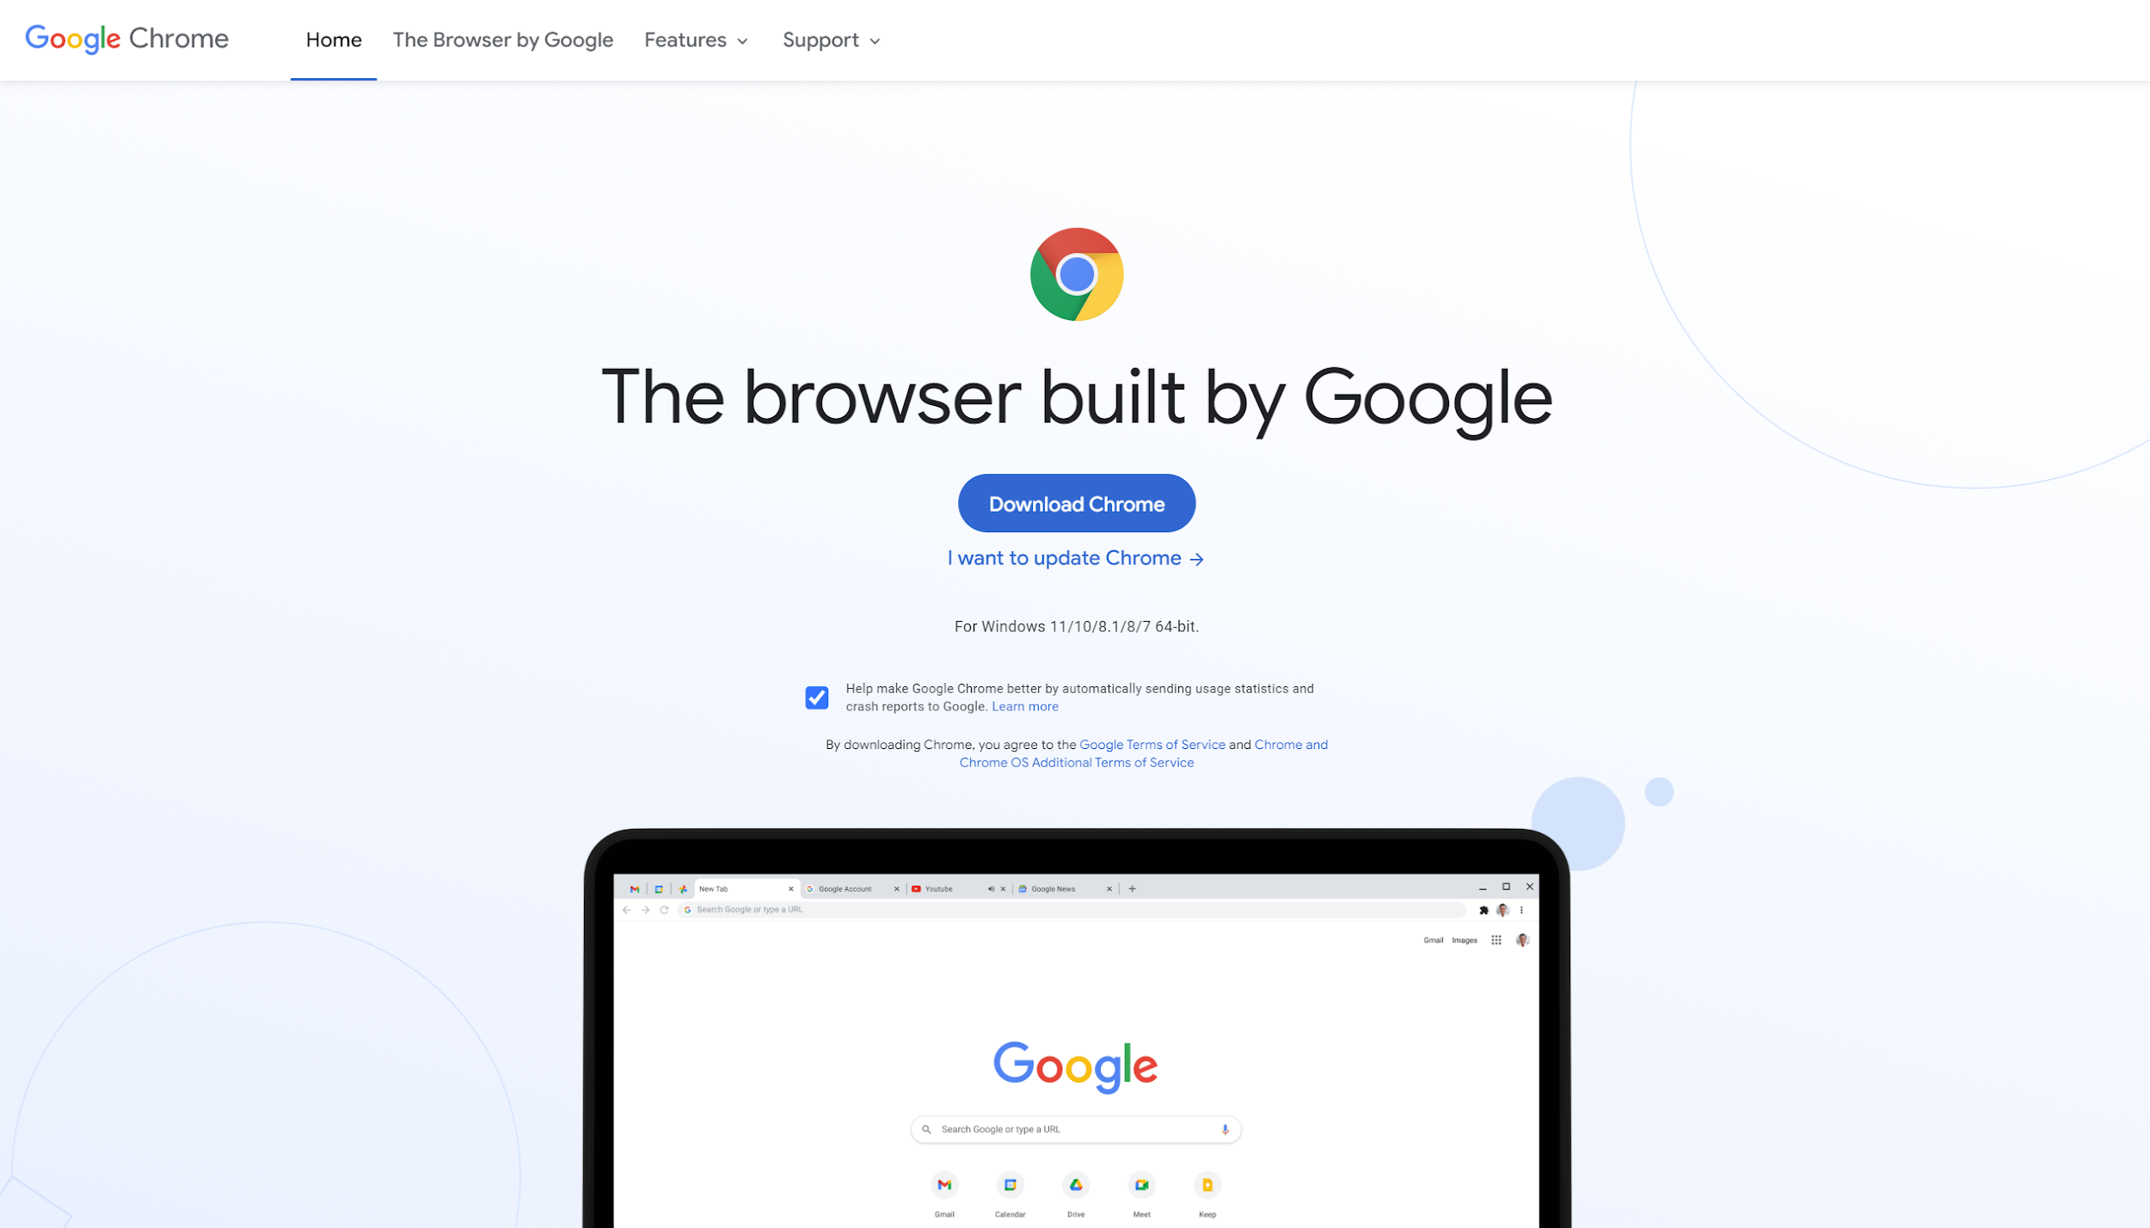

* Sticky navigation bar (Navigation bar sticks to top of screen during scroll)
* Unintrusive animated background
* Minimalistic
* Alternates between left and right justification to distinctly separate content
* ARIA-labels
* One-time animations + animated GIFs

### **Microsoft Outlook**

https://outlook.live.com/owa/

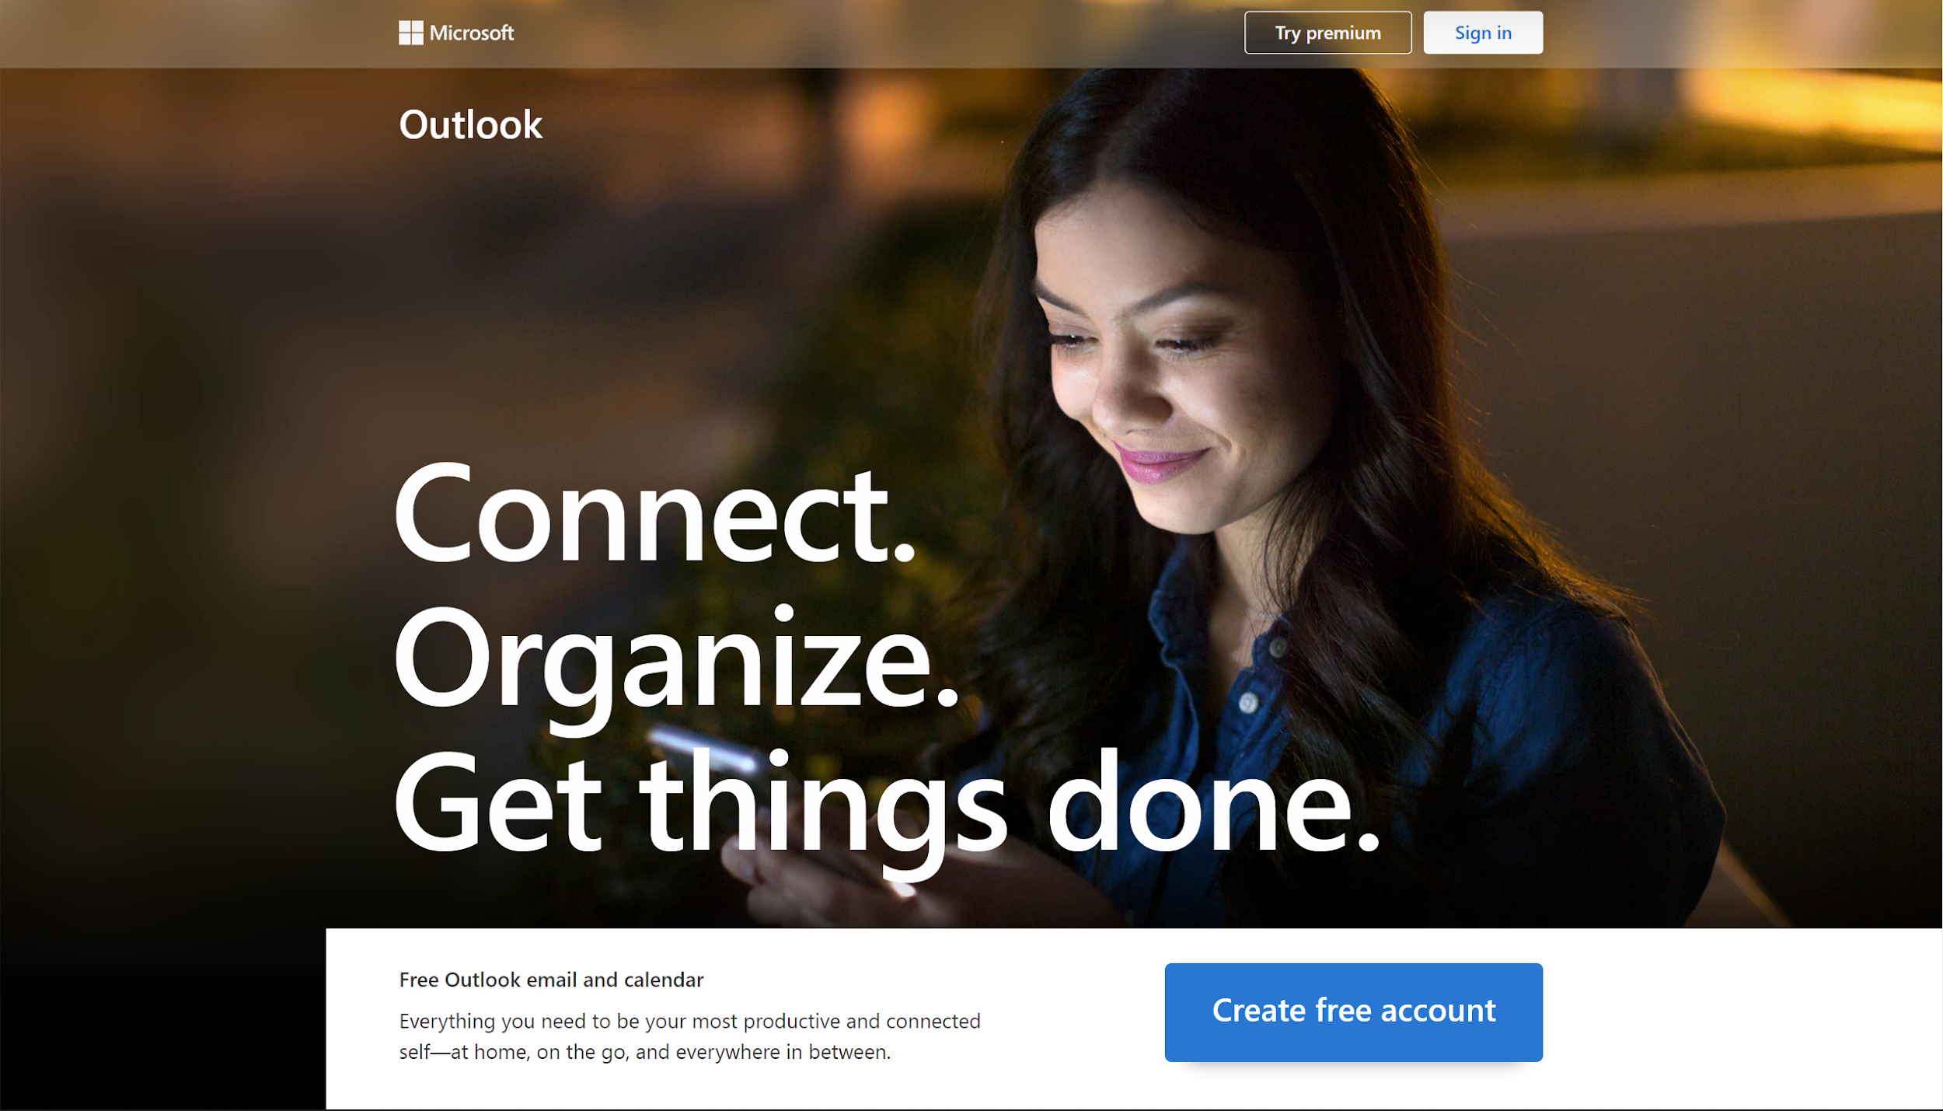

* Multiple animations which re-fire when elements are scrolled into view
* Non-traditional layout, overlapping “grids” and non-symmetric layouts create a more crowded but unique look
* New sticky nav bar appears after scrolling past the top navigation bar

## 2. Functionality:

### Login/Register pages:

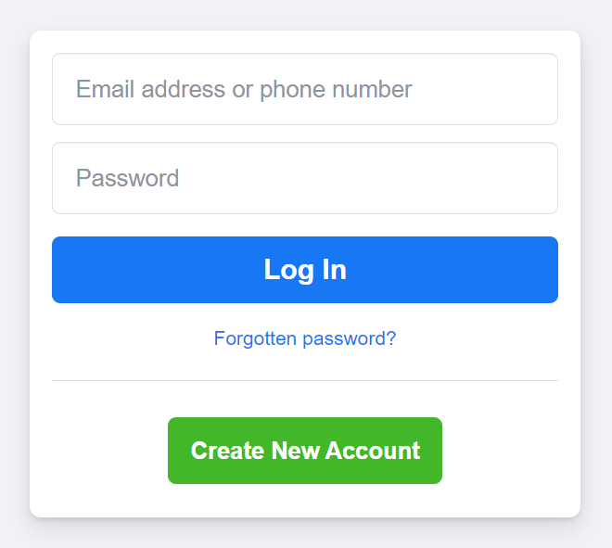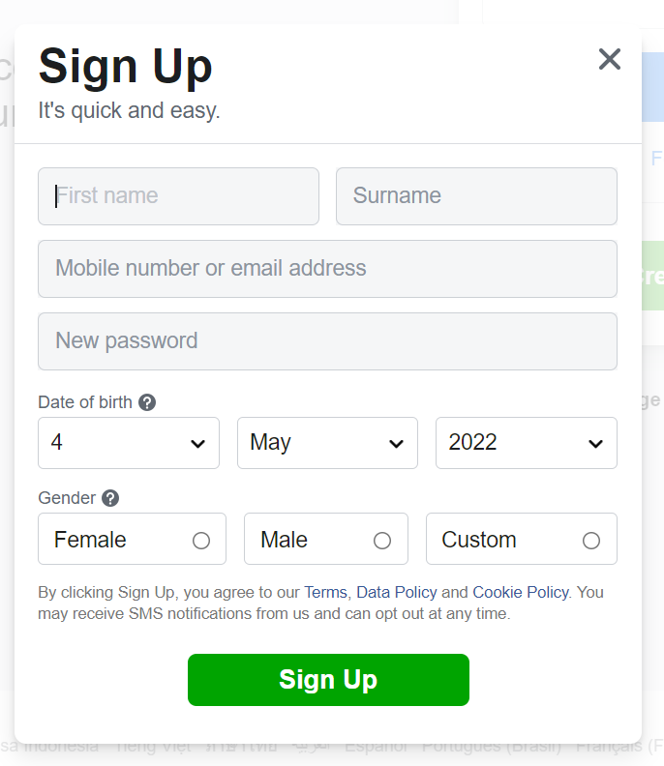

Facebook’s login and register forms.

### “Dashboards”, or our user’s main content page:

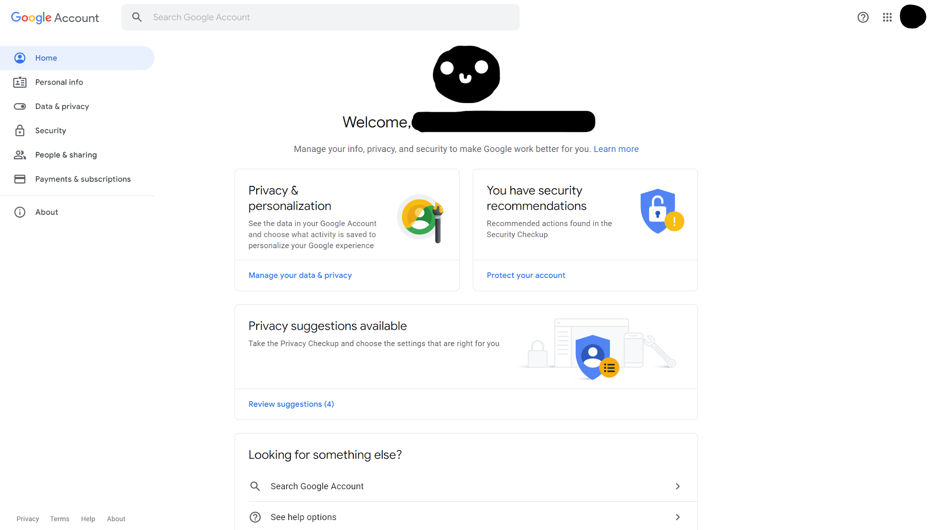 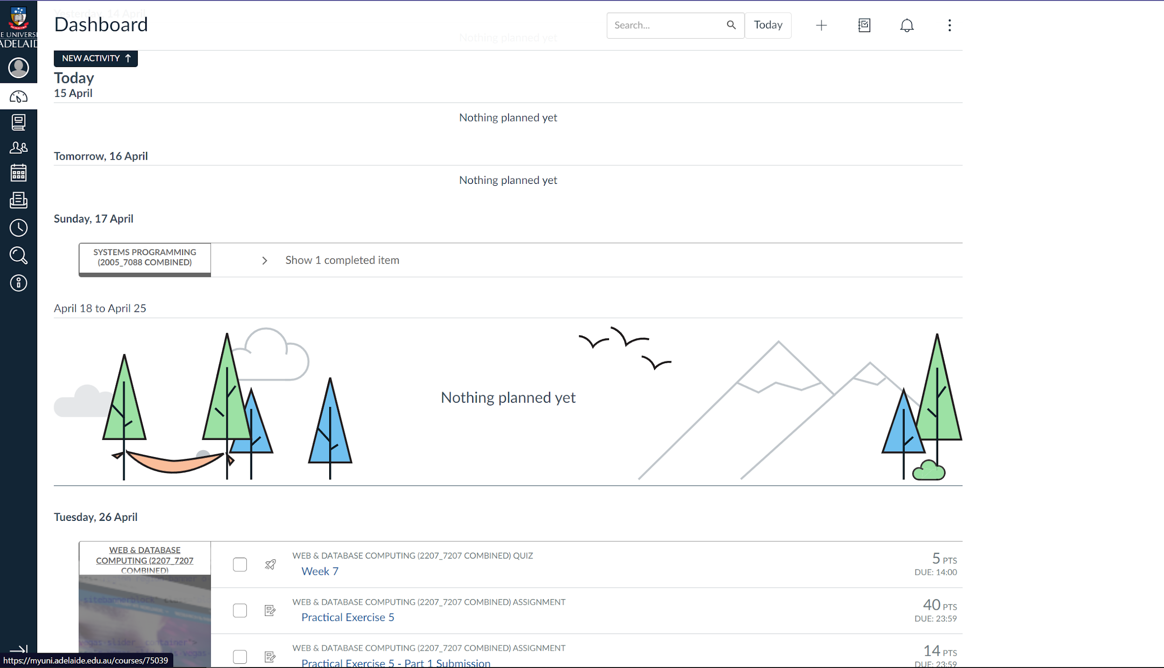

Google Account & MyUni Dashboards.

### Notes:

* Navigation links seem to be left-aligned on wide-screen devices, and may appear fully, or as icons, or as an expandable dropdown menu.
  + Mobile devices preferably use buttons with expandable menus to avoid taking up screen space
* Possible Links for a navigation bar:
  + Home/Overview
  + My Events / Events
  + Profile
  + Settings
* For our event planning app, the Dashboard should include an overview of our events.
  + Upcoming events should be prioritised or clearly visible on this page

## Event planning:

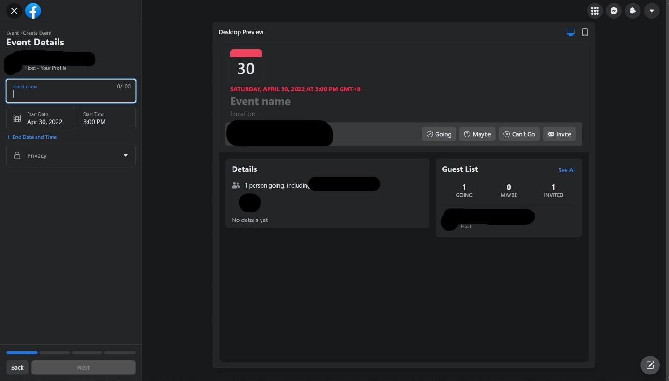

Above: Facebook’s event planning page.

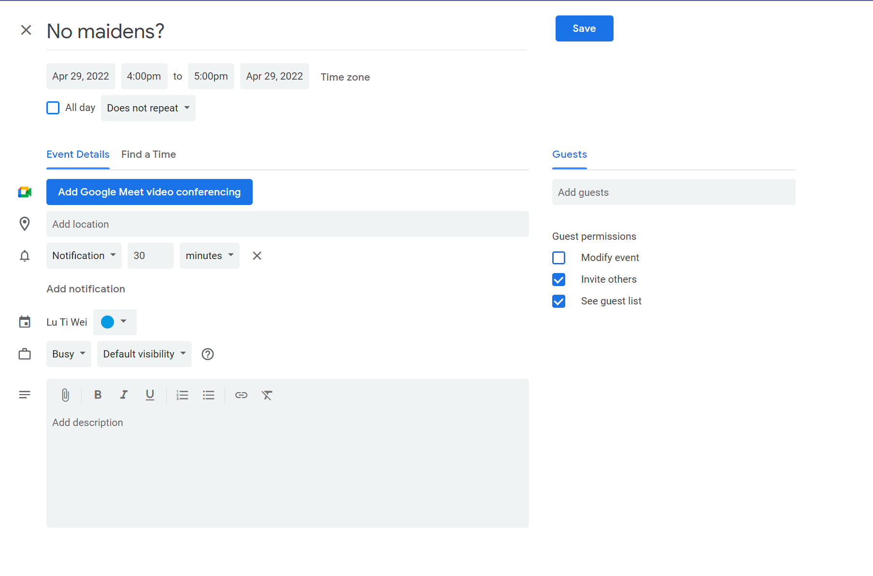

Google Calendar’s event planning page.

### Notes:

* Basic event information may include:
  + An event name
  + A start time (with an optional or compulsory(?) end time)
  + A guest/invite list
  + A description of the event

## Proposal:

Things that could be added to our project from these

* The way users sign-up was very simple and users do not have to supply a lot of information at the beginning.
* Theme used should be the same through-out.
* Colors like black and dark blue went quite well and were easy on the eyes. According to research, blue is actually one of the most liked colors out there as well(<https://99designs.com.au/blog/tips/website-color-schemes/#:~:text=Blue%3A%20the%20most%20versatile%20and,demands%20attention%20and%20stands%20out>.).

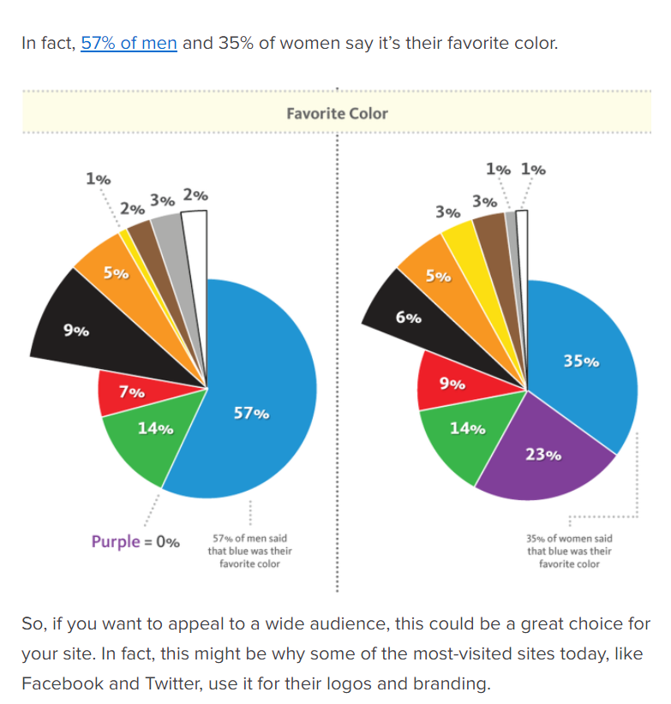

* Purple was quite a good color as well but we can maybe go with gray? Gray seems to be a viable option as well if we want to not look like the others, want to stand out from the crowd while keeping a mature and simple look.
* Phone numbers can be added in later in the account (email will be used primarily).
* Adding an event was pretty simple and the template for adding it could be used as a template for our project.
* Availability calendar seemed nice and quite easy, something like that can be added to our website.
* Main page should be to the point, with a navigation bar at the top middle, login on the right and name of the website on the left.
* Add any contact information (for support) at the bottom of the main page and at the top right navigation bar.
* Only users that have accounts get to access events, creating events and scheduling.
* The “workflow” page is something we can take from and add features that are similar to it (e.g: email notifications that update users [but only if they subscribe to get these notifications?]).
* There was an “integrations” page, but for the most part, our project will probably only use one integration method (Google Calendar?).
* Instead of creating an event being on a different page, a link to create an event could be next to schedule (maybe around the top?)
* Sharing events is pretty easy as a link (something we can hopefully implement).
* You cannot see another user’s events/available times. Rather, they can only supply you with an available time directly and confirm whether they can attend an event.
* Events will show up as separate items and the host will be able to see who is coming to the event upon clicking on the event that they had created to view its details.
* Things that are relevant are close together (scheduling and creating events should be close).
* A feature to specify what time zone you’re using?
* Admin: Should be able to do anything to anyone’s schedules and events?
* The advantage of using basic principles for the structure of our website and the layout means that the users will see things that they are used to and it will make the cognitive load lower (unless the low chances of them being first time users to these kinds of websites occurs). These staple structures and layouts are laid out in a way that minimized kinematic load and using these will help us blend in with other professional websites and seem more reliable.